**WinBUGS**

*BUGS = Bayesian Inference Using Gibbs Sampling*

* It uses Markov Chain Monte Carlo (MCMC) to fit statistical models.
* WinBUGS fits fixed-effect and multilevel models using the Bayesian approach.

**Bayesian Analysis**

Bayesian analysis is a statistical methodology rooted in Bayesian probability theory. It provides a framework for updating our beliefs about uncertain parameters in light of new evidence or data. Unlike traditional frequentist statistics, which relies on fixed parameters and focuses on the probability of observed data given fixed parameters, Bayesian analysis treats parameters as random variables with associated probability distributions.

The fundamental formula used in Bayesian analysis is Bayes' theorem. Bayes' theorem describes the probability of an event, based on prior knowledge of conditions that might be related to the event.

Bayes' theorem is used to update our beliefs about parameters of interest given new observed data.

The formula for Bayes' theorem is:

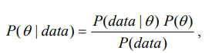

where θ is the unobserved parameter that we want to learn about using the observed data.

There are three important components:

* **The likelihood function [P( *data|*θ )]:**

The likelihood function quantifies how well the parameters explain the observed data. In other words, it provides a measure of the compatibility between the observed data and different sets of parameter values.

* **Prior P(θ)**:

The prior distribution, representing the initial belief or probability distribution of the parameters θ before observing the data.

* **The posterior distribution P ( θ *| data*):**

The posterior distribution represents our updated beliefs or knowledge about the parameters of the model given the observed data. It combines prior information with new evidence, providing a coherent and probabilistic framework for statistical inference.

Therefore, Bayesian data analyses typically involve the following ingredients:

(1) Specify a model that specifies the relation between the unknown parameters and the observed data.

(2) Specify prior distributions for the unknown parameters.

(3) Obtain the posterior distributions.

(4) Make inference using the posterior distributions.

WinBUGS (Win Bayesian Using Gibbs Sampling) is a software package that implements Bayesian analysis using the Gibbs sampling algorithm. Gibbs sampling is a Markov Chain Monte Carlo (MCMC) algorithm

**MCMC Model Summary:**

The key idea behind MCMC is to simulate a Markov chain in such a way that, in the long run, the samples from the chain converge to the target distribution. This allows practitioners to obtain approximate samples from complex probability distributions.

It provides a framework for updating beliefs about parameters given observed data, incorporating prior knowledge, and deriving posterior probability distributions. MCMC facilitates the sampling of parameter values from these posterior distributions, allowing practitioners to make Bayesian inferences.

**Algorithm:**

**Initialization:** Start with initial parameter values

**Proposal Distribution:** Define a distribution to propose new parameter values.

**Markov Chain Generation:** Iteratively update parameter values, accepting or rejecting proposals based on an acceptance probability.

**Repeat:** Continue the process for a sufficient number of iteration**s.**

**Convergence Monitoring:** Assess whether the Markov chain has converged to the target distribution.

With this approach, we can effectively generate samples.

Use the sampled values to estimate posterior summaries, such as means, medians, quantiles, and credible intervals.

**A typical WinBUGS program include three sections:**

**Model:** “model { … }” specifies the statistical model we are fitting.

**Data:** “list (s=650, n=1000) specifies the data.

**Initial Values:** specifies the initial values of the parameter.

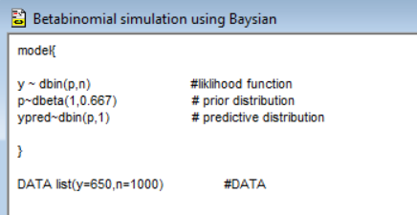

**Run the Analysis in WinBUGS**

1. Load model, data, and initial values:
2. Open a new document in WinBUGS and paste all three parts (model, data, initial values) on it.
3. Save the file as an .odc.
4. From the top panel: open Model ‒ Specification. A dialogue box will open.
5. Double-click (highlight) the word “model” in your file and click “check model” on the dialogue box.

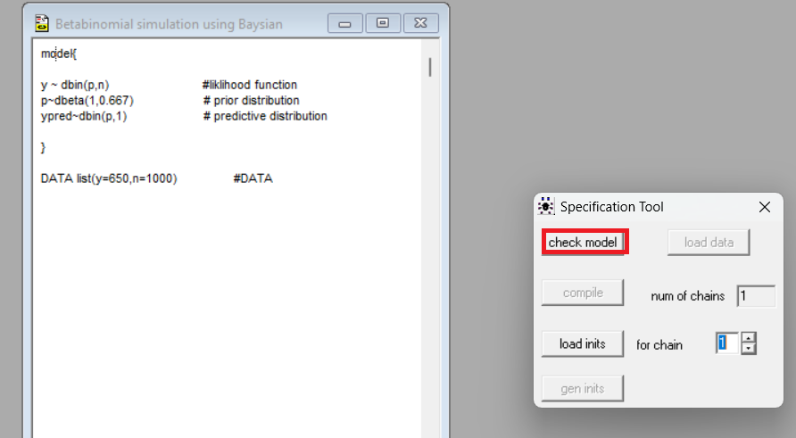

1. Look at the bottom left-hand corner for “model is syntactically correct.”
2. Highlight the word “list” for the data section and click “load data” in the dialogue box. Look at the bottom left-hand corner for “data loaded.”
3. 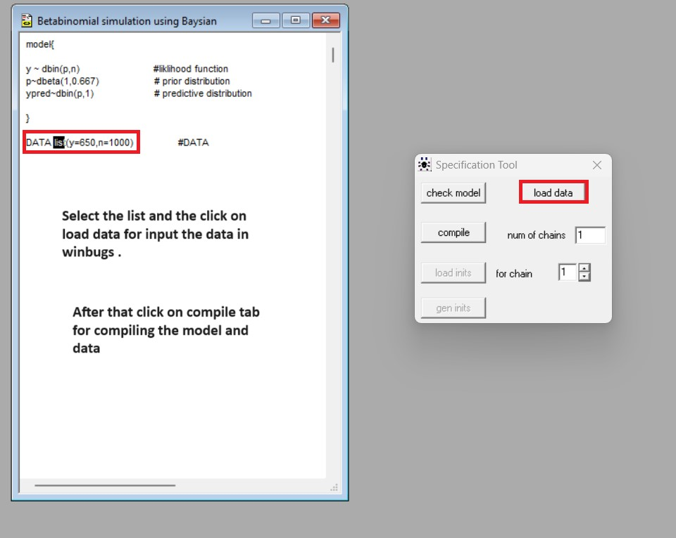
4. Click “compile” and look for “model compiled.”
5. Highlight the word “list” for the initial value section and click “load inits” in the dialogue. Look for “model is initialized.”
6. [Optional] If you did no initialize all parameters, click “gen inits” in the dialogue box.

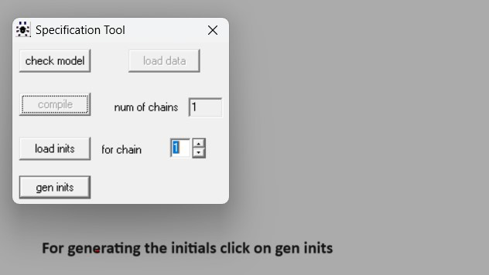

1. Run Sampler:
2. Open the “Sample Monitor Tool” window: Menu 🡪Inference 🡪Sample,
3. Type the parameters we are interested in the “node” box and click “set.” In this example we will track both “p” and “ypred”

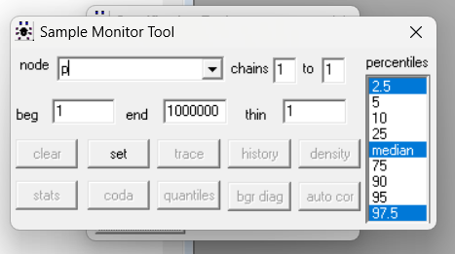

1. Open the “Update Tool” window: Menu 🡪 Model 🡪 Update.
2. In the Update Too box, type in the number of posterior samples you want in the “updates” box. E.g. 20000.
3. Click “Update” and watch it runs in the iteration box!

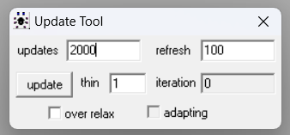

1. Posterior Inference:
2. In the “Sample Monitor Tool” select “p” or “ypred” from the drop-down box in “node.” Or type * for selecting the both node.
3. Select the number of initial samples that we want to drop in the “beg” box. This is also known as “burn-in.” Let’s choose 100 here.

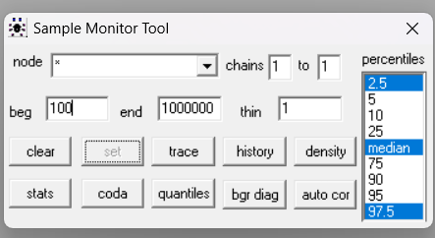

Now by choosing the appropriate option from window we can get desirable results.

For ex.

